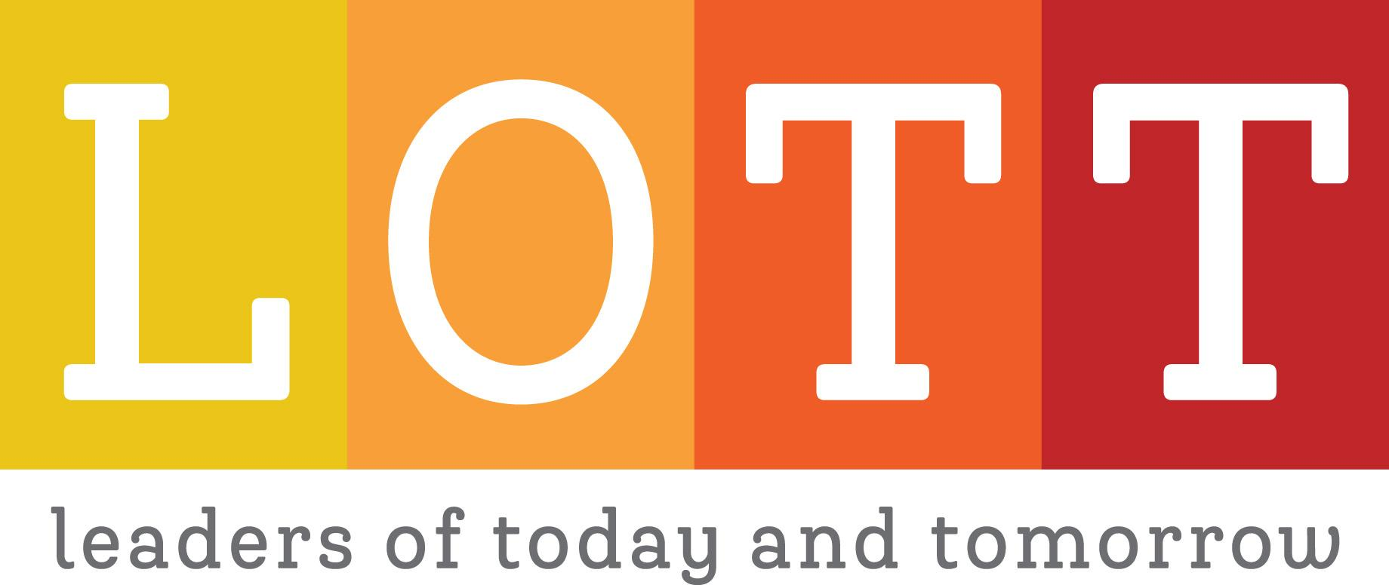

2025 LOTT Call for Speakers

Name:

Email:

Phone Number:

Title:

Organization:

Speaker Bio:

Workshop Title:

Workshop Goals:

Workshop Description:

What makes you uniquely qualified to present on this topic?

Availability - Please select the workshop sessions you are available for:

* Saturday, January 11, 2025 - Workshop 1
* Saturday, February 8, 2025 - Workshop 2
* Saturday, March 8, 2025 - Workshop 3
* Saturday, April 12, 2025 - Workshop 4
* Saturday, May 10, 2025 - Workshop 5